Laxmi Charitable Trust’s
Sheth L.U.J College of Arts & Sir M.V. College of Science and Commerce
Department of Information Technology (Bsc.IT Semester III)
Python for Data Science Practical

Practical - V
Roll No. : S010 | Name: ANJALI GUPTA
Class : SYIT | Batch : 1
Date of Assignment : 12/08/2026 | Date/Time of Submission : 12/08/2026

PART – B Practical Questions:
5a. Write a python code to demonstrate importing pandas libraries and create data frame object.
CODE:
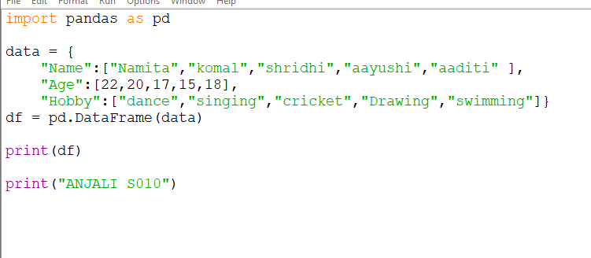
OUTPUT:
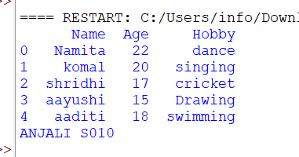

5b. Write a python code to show statistical information on given data set.
MEAN:
CODE:
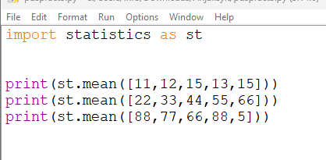
OUTPUT:
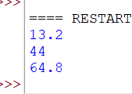
MEDIAN
CODE:
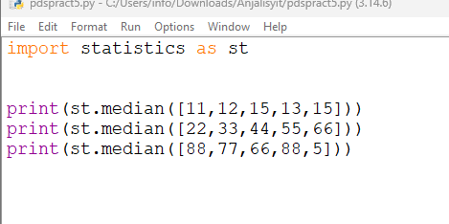
OUTPUT:
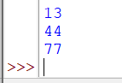
MODE:
CODE:
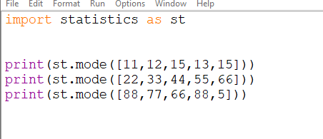
OUTPUT:
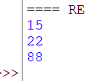
STANDARD DEVIATION
CODE:
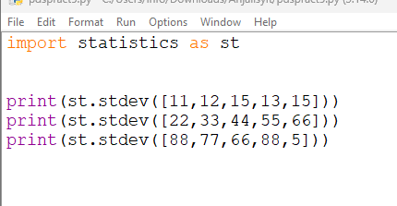
OUTPUT:
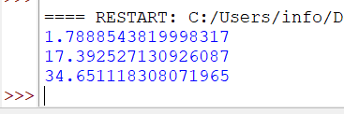
VARIENCES
CODE:
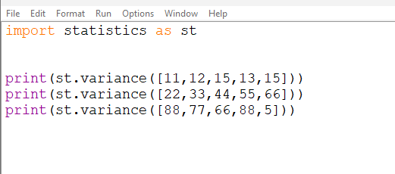
OUTPUT:
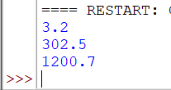

5c.Write a python code to create pandas series from dictionaries.
CODE:
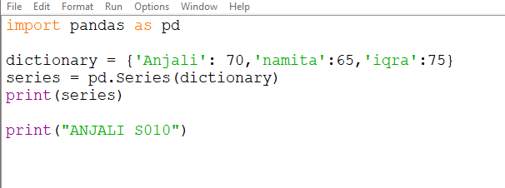
OUTPUT:
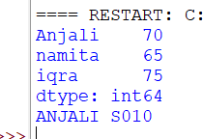
5d. Write a python code to demonstrate filter pandas series with Boolean arrays.
CODE:
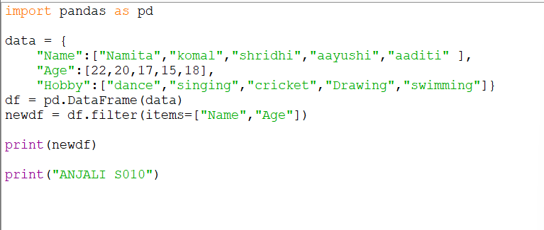
OUTPUT:
